**NEREB MARKING GUIDE**

**GEOGRAPHY ONE**

No.1

(a)

(i) col/ a conical hill

(ii) 1 1

212502

3 3

(b)

* Kabale is located between Eastings 20 an 34 and nothings 48 and 62
* According to 1020’s on the map of Kabale, indicates that Kabale lies in the southern hemisphere.

No.c

Solution;

Org length = 27.8

Org width = 27.2

Reducing factor 1/3

Length = 27.8 cm = 9.26cm

3

Width = 27.2 cm = 9.06

3 = 9.1cm

New scale

1 d(i)

* Acts as educational enter as evidenced by schools at …….
* Acts as industrial center as evidenced by a factory at ……
* Provides security to its people evidenced by police and banks.

1.d(ii)

* Radical drainage pattern. This is where the streams originate from one point at a highland which acts as a center and flows to different pars in the low land.

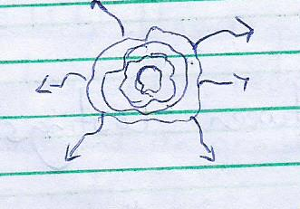

d(iii)

* Steep slopes evidenced at
* Sordles evidenced at
* Col evidenced at
* Gentle slopes at Kabale town.

No.1. c

AREDUCED SKETCH MAP BY 1/3 OF KABALE, ON IT MARKING AND

NAMING PHYSIOGRAPHIC REGION, LAKE BUNYONYI, A PLANTATION FARM, ALL WEATHERED LOOSE SURFACE ROAD AND RIVERS ON RWABURIGITA HILL AND KABALE TOWN.

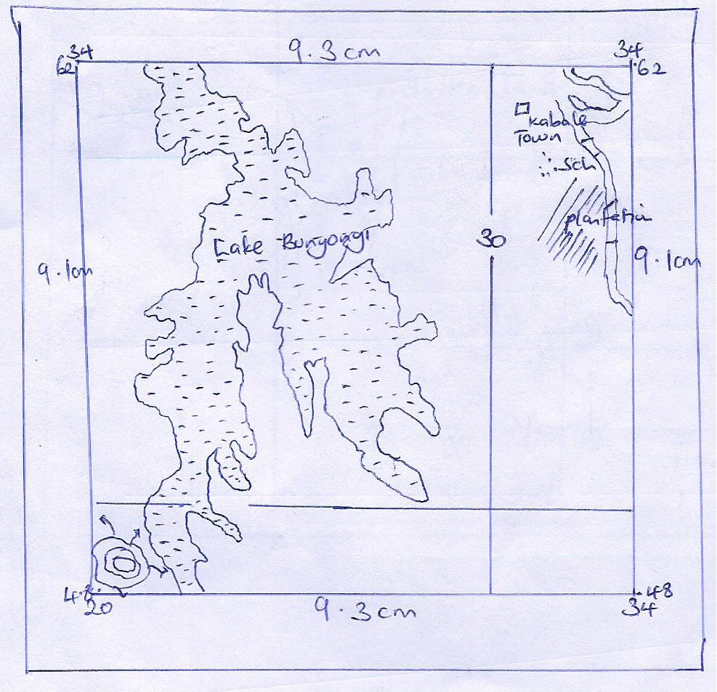

No. 2a)

A LAND SCAPE SKETCH OF THE PHOTOGRAPH SHOWING PHYSIOGRAPHIC REGIONS AND LAND USE TYPES

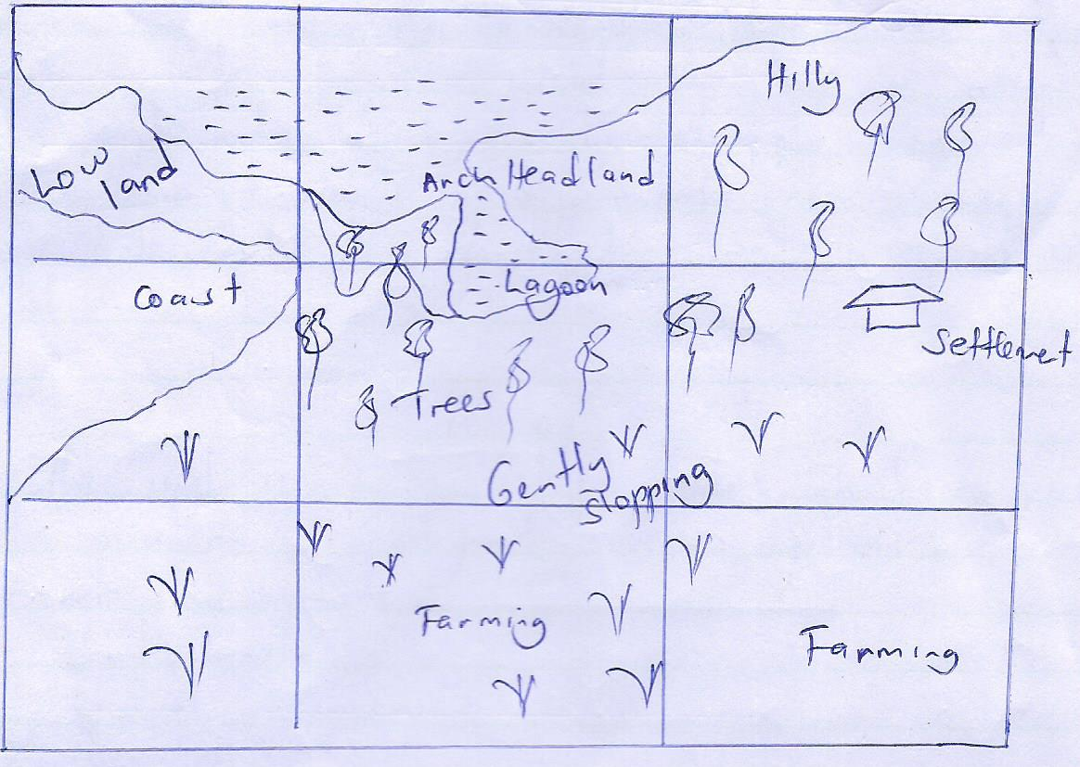

No. 2.b

The feature in the right back ground is a lead land/Bag

* Head – lands are indented coasts where water either projects into the lands. They are formed where there are alternating hard and soft rock which lie t right angle to the coast. They are as a result of differential erosion of soft rocks where the eroded rocks are forced to curve into which is the sea or lake.

No. 2.c

The influences of the relief feature on human activities in the area on the photograph are as follows:-

* Acts as tourism
* Wind breaker
* Research purposes
* Store quarrying/mining

No. 2.d)

* Habour dangerous animals
* Limits transport and communication
* Rampant to accidents
* Pests and diseases.

No. 2.e)

Kasenyi fish landing site on the shores of Lake Victoria in Wakiso district.

No. 5a)

Vertical erosion; this occur when a river concentrate on ending its bed vertically and this happens in the youthful stage of a river due to increased speed resulting from the steep gradient thus leading to valley deepening.

While;

Lateral erosion; this leads to valley widening and creation of a U – shaped valley. This involves erosion of the sides and it occurs when the river energy has reduced the deposits some of its load and concentrate on erosion of its valley sides.

5b).

V-shape valley; these refers to the valleys in the upper course of the river that have been undercoat by vertical erosion. The rocks in the bed are always softer than lateral erosion example include R.Mubuku, Nyamugasani on Mt. Rwenzori



Waterfalls refer to a harp break in the channels bed over which the river flows. It’s found in the youthful stage of a river. It can be formed where vertical or horizontal bands of hard and soft rocks ie across a river bed .g Ssezibwa falls in Lugazi and Sipi in Kapchorwa

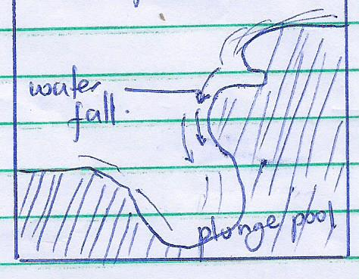

A rapid, refers to a physical feature formed if the bond of a hard rock I steep or slanted across the river bed but not vertical e.g Bujagali.



Interlocking spurs, this refers to the river twists and twins formed around obstacles of hard rock’s along the river channel, due to the river taking winding course e.g.

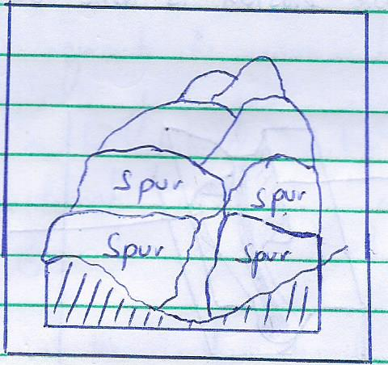

Pot holes; refers to the cylindrical holes formed by action of pebbles being hausted against on even bed of fast flowing river example can be seen on R.Manafa in Eastern Uganda R.Mubuku in western Uganda.

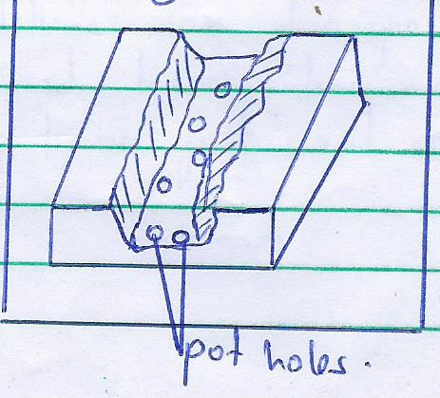

Gorges; a gorge is a steep sided hollow, found where a river flows fast due to the steep gradient resulting into vertical erosion e.g can be seen a Kyambura gorge in Queen Elizabeth National park, Murchison falls on the Victoria Nile.

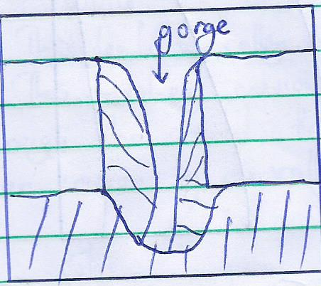

Diff; refers to the cut spur ends extended down into the river valley. They are formed when a river erodes laterally to widen its valley; more erosion is done on the concave bank thus creating a cliff.

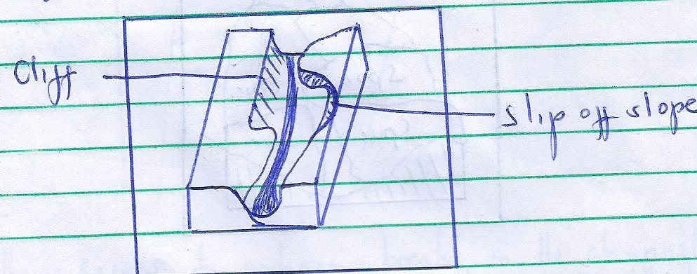

No.8

* Soil formation processes are the various activities that act upon the parent rock and organic matter to produce soil. There include;-
* Weathering; this is the disintegration and decomposition of rocks under the influence of rainfall and temperature. Physical weathering disintergrates rocks into simple substances that may differ from the parent rock therefore forming deep and mature soil. In areas of Kabong, moroto, central Kenya and Tanzania.
* Leaching; this is the removal of soluble mineral nutrients from the upper layers of the soil profile to the under lying layers of soluble nutrients like salt, iron, carbonates among others are removed and transported in a solution form to form the A horizon making horizon acidic soils
* Elluviation; this refers to the movement of soluble material in solution or suspension form from one place to another within the soils. Movement can be vertical as it is the case with leaching. This is influence by climate and nature of the parent rock loading to poor A – horizon known as elluvial zone.
* humification; this is the process through which organic matter is decomposed to for humus a task performed by soil living organisms like bacteria earth warm, termites etc. it is commonly in humid areas with heavy rainfall and hot temperatures.
* Mineralization; this is the process of soil formation which takes place in extreme conditions where decomposition of organic matter that forms humus beyond humification such that organic matter is broken down into basic parts and changed into mineral subsistence like carbon dioxide.
* Calcification; it is a process which takes place in dry places as a result of upward movement of capillary war where evaporation exceed precipitation. The excessive evaporation cause water containing dissolve calcium to move upward through soil by capillary action forming shallow soil profile with well developed soils rich in calcium known as pedocals.
* Globalization; this occurs in wt/cool climate region with poor drainage especially in the swampy areas. They occur as bluish grey with sticky day soils due to reduced oxidation leading to shallow soil profile.
* Lateralization; this involves weathering under hot an damp conditions within the tropics. This is a process in humid areas that involves the migration of soluble mineral nutrients from the upper layers to the underlying areas silica is loaded from A- horizon leaving behind iron, leading to laterite soils.
* Prodolization; this is a complex oil forming process that occurs under cool moist climatic region which involves leaching of salt and iron compounds leading to formation of podozoic soils.

Continue with No.4

Volcanicity is a complex process which involves the movement of gaseous materials, ash, pyrodests and hot molten magma caused by radioactive and geochemical and geophysical which result to increased heat and pressure within the crust hence forcing the hot molten magma move inform of convective currents through the fissures onto the earth’s surface. The resultant volcanic features are as follows;-

* Volcanic pug; are steep sided volcanic plug is formed when the vicious magma is extruded out as a rigid cylindrical mass a midst clouds of hot ash and cinders which quickly solidifies to form a volcanic plug e.g Tororo rock and Alekileki rock in Kotido.

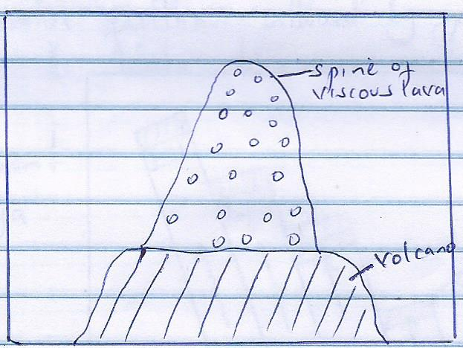

Lava plateau is upland with more or less monotonous relief composed of different/successive layer of lava. It is formed when basic fluid lava flows out through several fissures from the earth’s crust and spread at over a long distance before solidifications as a sheet of basalts, .g it is en at Larkipia plateau in eastern slopes of Abardera ranges in Kenya.

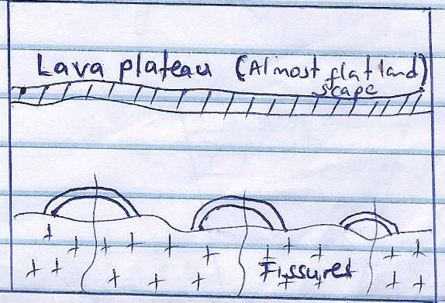

Inselbergs; an inselberg is a residual isolated hill in a generally flat plain. It is formed when the batholiths is expose by denudaitonal forces of running water in a flat land to form a residual hill after the eroding of soft rocks standing above the ground s an inselberg.

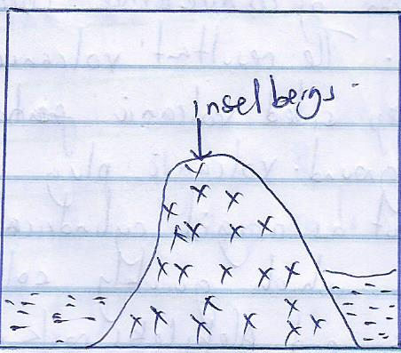

No.4

* Highlands are have different processes of formation such as faulting, volcanicity and folding as explained below;-
* Faulting refers to the fracture, rapture of the earth’s crust into permanent dislocation and displacement of crustal blocks. Faulting is caused by tensional or compression forces which are generated by radioactive and geo-domical reactions within the earth’s interior which load to the rise of molten rocks. The following are the features of faulting.
* Tilt blocks; this I an upland with inclined top surface. It is formed by either tensional or compressional forces which create multiple and parallel fault lines followed by general uplift at different intervals;-
* Therefore the block which are rised higher are called tilt blocks.e.g

Nandi escarpment in Kenya

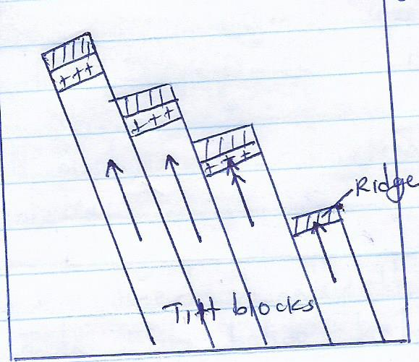

Block mountains; this is also referred to as a host mountain. Block mountains refers to an upland surrounded by series of fault scarp standing above the surrounding land e.g mt. Rwenzori in Uganda Pare in Tanzania, Usambaara, Uluguru, Mathew hill in Kenya. Block Mountains are formed by tensional and compression forces

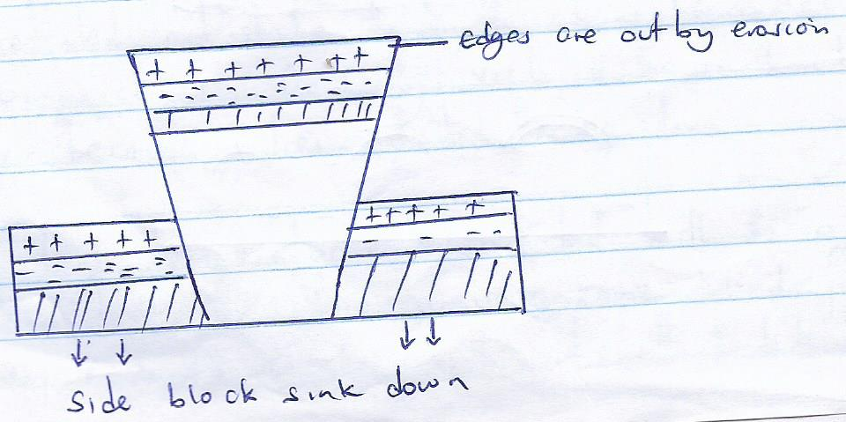

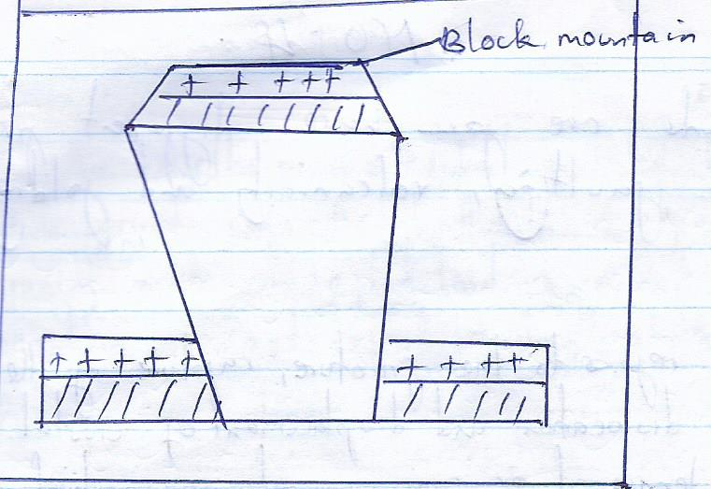

**No.6**

* Climate is the average weather condition of a given place studied recorded over a long period of time ranging from 35-40 years. It involves studying and recording of weather elements like temperature, rainfall, pressure.
* The types of climate are equatorial climate found around water bodies in areas of around L.Victoria characterized by well distributed rainfall throughout the year ie over 1000m per annum, high humidity, small durnal temperature range.
* Modified equatorial climate in confirmed in mountainous areas e.g long mountains like Rwenzori, mufumbira characterized by moderate amount of rainfall throughout the year. Relatively reduced temperatures and high humidity
* Tropical savannah climate covers the biggest part of east Africa. It is experience in Nakaawagola, Sembabule characterized by alternate hot and wet season, relatively low rainfall total amounts not exceeding 1000mm p.a and high temperature.
* Desert – sem desert climate; it is experience in north eastern Uganda like Kotido, Kabong characterized by low and unreliable rainfall amount constantly high temperature during ay, low humidity and high dunnal temperature range.
* Lattitude influences climate of east Africa; it refers to the equi-angular distance from the equator. Areas near the equator e.g Kayabwe, Jinja have high temperatures than areas for from the equator. Along the equator, the sun’s rays are more concentrated and strike the earth at right angles leading to high temperatures. Generally Vitoria basin has high temperatures because it lie astride the equator
* The high temperatures associated with the equatotorial altitudes ten to create a low pressure zone. Winds from the high pressure zones ie the north and south ten to blow towards and converge in this law pressure zone called the inter-tropical converge zone (ITCZ) convergence of these winds bring heavy rainfall in many parts of east Africa. The low pressure zone is created by the sun insolation. Since the sun tend to move a few degrees north and south of equator so does the (ITCZ)
* when the sun is over head, in the northern hemisphere Gulu an wt Nile receives rainfall in the month before and after July and when the un is over head in the southern hemisphere, southern Uganda regions like Ntungamo, Rakai, Kabale receive rainfall round December and January.

The climate of east Africa is also influence by other factors as shown below;

* Water bodies inform of lakes, rivers and swamps greatly influence the climate of east Africa through rainfall formation. Through evaporation, L.victoria recharges the south east trade winds. S the winds move higher they cool and condenses into rainfall which is received in the areas of Kalangala island n northern shores of L.victoria particularly at Entebbe, Lugazi, Jinja, etc.
* Winds the south east trade wins pick moisture from the Indian Ocean and forms heavy rain along the coastal lands and northern shores of L.Victoria. The western lies/Zaire air stream from Congo bring heavy rainfall to south western Uganda particularly Kisoro, Kable and Bushenyi region hence equatorial climate. As they continue in the interior they cause aridity in the Ankole-Masaka corridor due to lack of moisture hence tropical climate in the region.
* The Harmatton winds from Sudan and north east trade winds from Ethiopia are dry and therefore tend to promote aridity in the north and north eastern Uganda for example Kotido, Kabong, Kitgum.
* The north east trade winds loose moisture along the northern slope of Ethiopia highlands and therefore descends to the southern slopes as dry winds.
* Continentally or distance from the sea and lakes also affect the climate of Uganda. Areas near water bodies tend to receive heavy rainfall due to land and sea breezes. This influences rainfall and temperature adjustments. During the night, the land cools faster than the sea. Hence temperatures are cooler over land than the sea which retains much of the heat. Low pressure is created over the warm sea and high pressure over the colder land. Wind blow from the higher pressure zone to the low pressure zone as land breeze. This brings rainfall an cool temperature and may form fog over the seas during the day, cool an moisture winds bow toward land causing rainfall or drizzle to areas near the sea Lugazi, mukono and Entebbe have more rainfall than the continental areas a far away such as Kotido because they are near L.Victoria and so experience he breeze.
* Relief also influences the climate of east Africa. The warm, moist winds are forced to rise when they blow toward a mountain and the process the moisture cools and condenses into orographic rainfall and the wind ward side. However, the lee ward side is left in the rain shadow and may experience arid conditions. Orographic rainfall is received on the western and southern slopes of Mt.Rwenzori while the northern slopes and eastern receives very little rains. This explains the aridity of semuliki and Albert flats in the north of Rwenzori and the Kasese –Fortportal regions. Similarly along Mt.Elgon rainfall is received on the western slope while the eastern side in Kenya is left dry. This has led to occurrence of montane or modified equatorial climate.
* Vegetation in form of forest, swamps and savanna woodlands also affects the climate of Uganda. Through evaporation – transpiration lot of moisture is released into the atmosphere by the vegetation. This rise up cools and condenses to form clouds which late precipitates into convectional rainfall to areas adjacent to thick vegetation. This partly explains why areas near mabira, Budongo kalangala forest almost receive rainfall everyday hence equatorial climate.
* In conclusion latitude influence climate to a less extent and also other factors influence climate as shown above.

**No.7**

* Define natural forest
* Examples of natural forests in east Africa and location
* How has altitude influenced natural forests
* Natural forests are forests which exist artificially e.g montne forests found in highland areas such as mt. elgon , Ruwenzori, muhavura, Tropical low lands forest are found along the equator and shores of lake victoria eg mabira, Budongo, malamagambo etc savannah woo land forests.
* Altitude is a factor that influences the distribution of natural forest. Tropical law land forests thrive in areas of low altitude for example along altitude. For example along Victoria basin, mountains such as Ruwenzori and elgon survive in high altitudinal areas well above 1500m above sea level.

Other factors also influence the distribution of natural forests s shown below;-

* Climate plays a significant role influencing the distribution of natural forest. Tropical low land rain forests thrive under hot wet and humid conditions for example around L.Victoria where mabira and Buggala forest in Kalangala exist. Tropical highland forests/montain forests survive under coal and wet conditions which are only found in highland area like mt. Elgon, Rwenzori where mt. elgon forest exist in mbale, Ruwenzori forest in kasese etc.
* Drainage also influence the distribution of natural forest vegetation mountain and tropical lowland forest survive in well drained soil. Rivrine forests grow along courses of major rivers such as the Nile, katonga and mayanja, savvanna woolnd forests grow in areas of fairly well drained soil for example in northern Uganda at Otze forest in Moyo and mt. Kei forest in Koboko
* Soil influences the distribution of natural forest vegetation in that all natural forests require deep and fertile soils to facilitate their luxuriant growth n great heights. Savannah woodlands forests survive in well drained oil for example in northern Uganda at Otze forest in Moyo and Mt.Kei forest Koboko.
* Human factor have also influenced the distribution of natural forest vegetation. Tropical low lands forest have been reduced through the man’s activities like creation of agricultural land e.g Butamira forest in Jinja is being out down for growing of sugar canes by kakira sugar cane plantations. Forest in Bunya, Mayuge re being cut down to control tsete infestation, Bush fire, road construction e.g the Kapala-Jinja road in mabira forest; lumbering have all reduced equatorial forest.
* Biotic factors have also influenced the distribution of natural forest vegetation. Wild blousing animals such s the giraffe and elephants have also reduced the formerly equatorial forests to savannah woodland or grass. The Murchison fall national park is good example of an area conquered by wild animals. Elephants destroy tree in Timu forests on the wild animals disperse tree seeds leading to extension of these forests.